**Submission Form**

**Fill up the following slots with appropriate content. You must submit the content of this document from this page only.**

1. Your Name: Mohammad Shafkat Hasan
2. Your ID: 19101077
3. Your Section: 04
4. Experiment No: 02
5. Experiment Title: To verify Ohm’s Law.
6. **You must write your ID in each of the graphs you insert here.**
7. **Data Table 1**:

$$R_{1 }=776 Ω$$

|  |  |  |
| --- | --- | --- |
| **Sl:** | **Voltage, V (volt)** | **Electric Current, I (mA)** |
| 1. | 1.0 | 1.3 |
| 2. | 2.0 | 2.6 |
| 3. | 3.0 | 3.9 |
| 4 | 4.0 | 5.2 |
| 5 | 5.0 | 6.4 |
| 6. | 6.0 | 7.7 |
| 7. | 7.0 | 9.0 |
| 8. | 8.0 | 10.3 |
| 9. | 9.0 | 11.6 |

1. **Data Table 2:**

$$R_{2 }=707Ω$$

|  |  |  |
| --- | --- | --- |
| **Sl:** | **Voltage, V (volt)** | **Electric Current, I (mA)** |
| 1. | 1.0 | 1.4 |
| 2. | 2.0 | 2.8 |
| 3. | 3.0 | 4.2 |
| 4 | 4.0 | 5.7 |
| 5 | 5.0 | 7.1 |
| 6. | 6.0 | 8.5 |
| 7. | 7.0 | 9.9 |
| 8. | 8.0 | 11.3 |
| 9. | 9.0 | 12.7 |

1. **Data Table 3:**

$$V=3.9 volt$$

|  |  |  |
| --- | --- | --- |
| **Sl:** | **Resistance, R (Ω)** | **Electric Current, I (mA)** |
| 1. | 100.0 | 39.0 |
| 2. | 200.0 | 19.5 |
| 3. | 300.0 | 13.0 |
| 4 | 400.0 | 9.8 |
| 5 | 500.0 | 7.8 |
| 6. | 600.0 | 6.5 |
| 7. | 700.0 | 5.6 |
| 8. | 800.0 | 4.9 |
| 9. | 900.0 | 4.3 |
| 10. | 1000.0 | 3.9 |

1. Draw I vs V graph for Data Table 1 and 2, that is you plot V along the $x$-axis and I along the $y$-axis. For two tables you will get two straight lines. Draw them as separate graphs. Find the slope of each line. Insert **graph-1** (for R1) and **graph-2** (for R2) as image here:

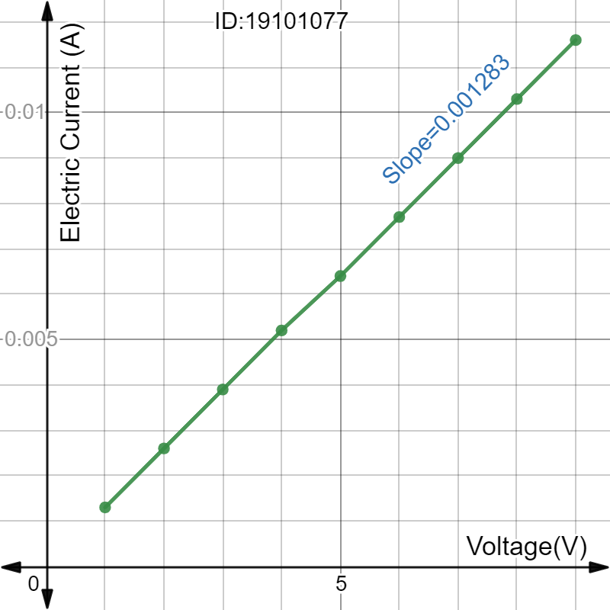

Graph-01

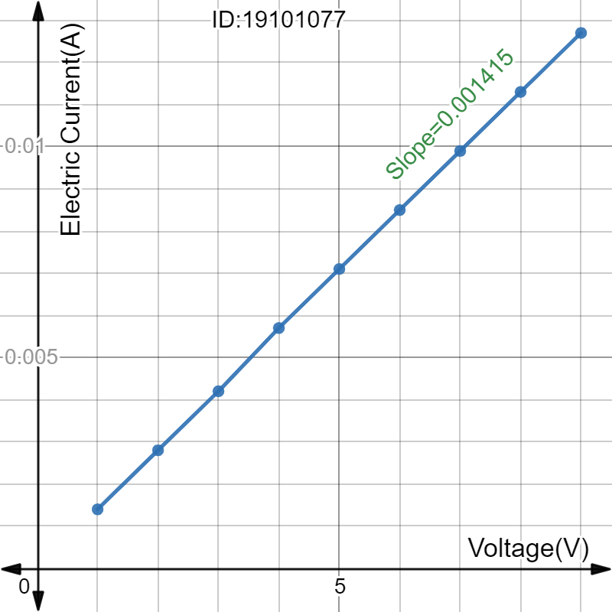

Graph-02

1. For Data Table 1,   
   Slope = 0.001283   
   Calculated value of resistance, R`_1 = 779.4232268 Ω  
     
   Percentage of error = [ | Calculated Resistance - Given Resistance| / Given Resistance ] * 100 = [ |R`_1- R_1|/R_1 ] * 100 = 0.44 %  
     
   For Data Table 2,   
   Slope = 0.001415   
   Calculated value of resistance, R`_2 = 706.713809 Ω  
     
   Percentage of error = [ | Calculated resistance - Given resistance| /Given Resistance ] * 100 = [ |R`_2 - R_2|/R_2 ] * 100 = 0.04 %
2. Draw I vs R graph for Data Table 3, that is you plot R along x-axis and I along y-axis. You will get a hyperbolic curve. Insert **graph-3** as image here:

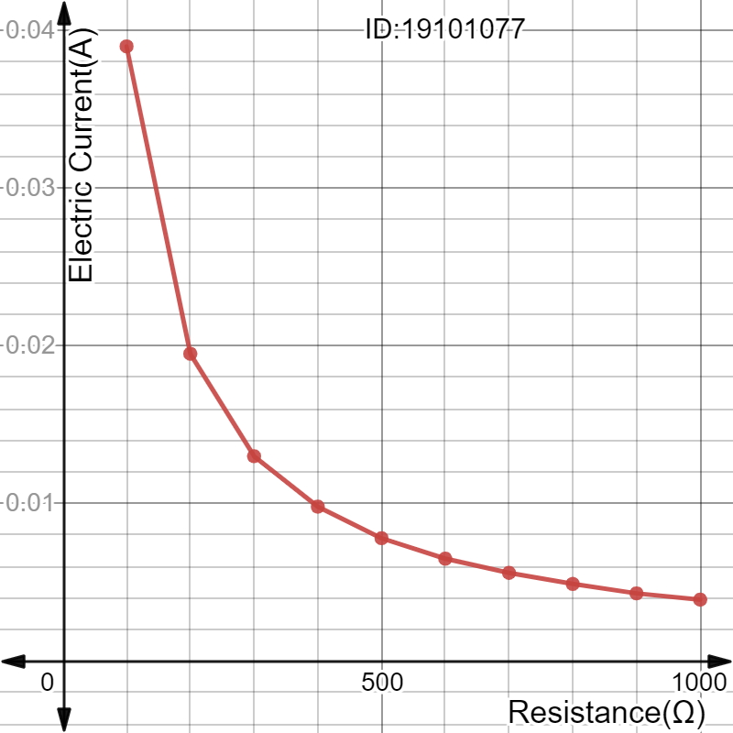

Graph-03

You are ***strongly*** encouraged to use your **own words** to describe your thoughts. **However, any kind of plagiarism (such as copying and pasting from other students’ lab-reports) will not be tolerated and will be subject to disciplinary action according to BracU policy.**

Please briefly answer the following questions:

1. Explain why you see a hyperbolic graph in step 12.  
   Ans:  
   Graph-03 is Electric Current(A) vs Resistance(Ω) which creates a hyperbolic graph. If resistance is varied for a constant voltage, the current versus resistance curve plots a hyperbola. We know V=IR and I is inversely proportional to R. So, graph-03 of I vs R is a hyperbolic.
2. What assumption do you have to make about the temperature for Ohm’s law to hold true?   
     
   The main criteria for Ohm’s law is to keep the resistance constant because proportionality constant in the relationship is resistance R. But we know that the variation of temperature affects the value of resistance so to keep the resistance constant during experiments of Ohm’s law the temperature is considered constant.

V = I R

1. Sketch **I-V** graphs for materials for which:   
   a. Resistance increases linearly with temperature  
   b. Resistance decreases inversely with temperature  
   Explain your reasoning in both cases. We are only interested in an explanation for the shape of the graph.  
   [Hint: In the I-V graph, resistance is held constant. Resistance changes with temperature. So, you have to draw successive lines in the I-V graph for different resistances (for different temperatures). As you guessed it, the slopes will change. You can draw several lines in the same type of graph - one graph for (a) and another for (b).]   
     
   Discuss Here:  
     
   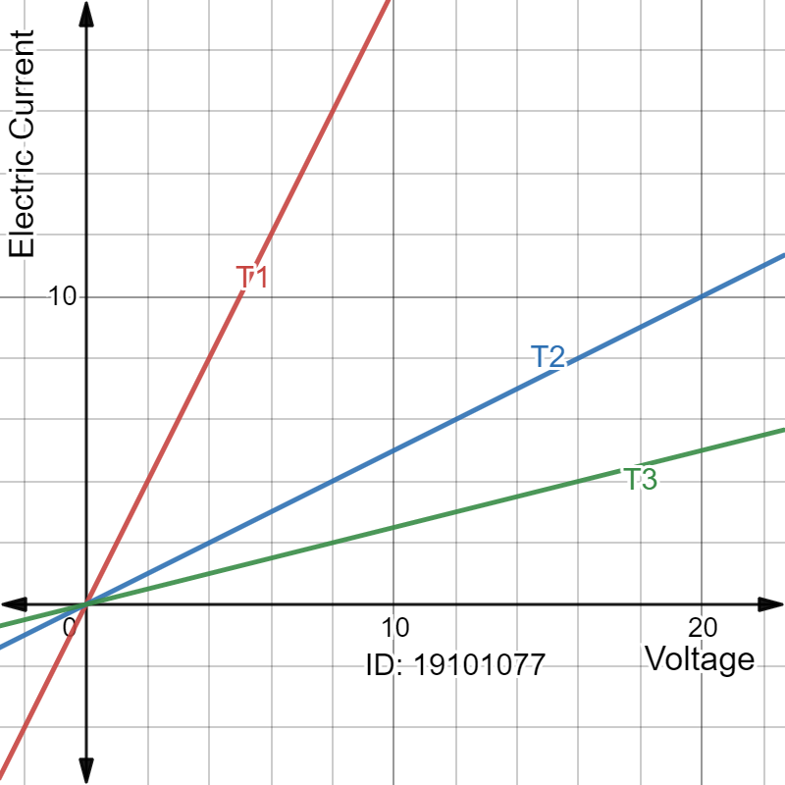

Graph-04

In this I-V graph different temperatures T1, T2, T3. Here, T3>T2>T1.   
Here, T1 is the lowest temperature where electric current (I) maximum and voltage (V) lowest. At, T2 temperature we get a lower electric current than T1 but voltage incenses. Lastly, at T3 we get the lowest current flow and highest voltage.

According to Ohm’s low, R = V/I and Resistance R = f(T)  
Resistance depends on the geometry of a conductor as well as on what the conductor is made from, but it also depends on temperature. Resistance generally increases with temperature.  
Furthermore R = Ro (1 + a DT) where R = resistance for heat and DT = temperature change. So, resistance and temperature are proportional.  
  
Finally, we can say that if we increase the temperature the resistance also increases. Similarly, resistance decreases inversely with temperature.